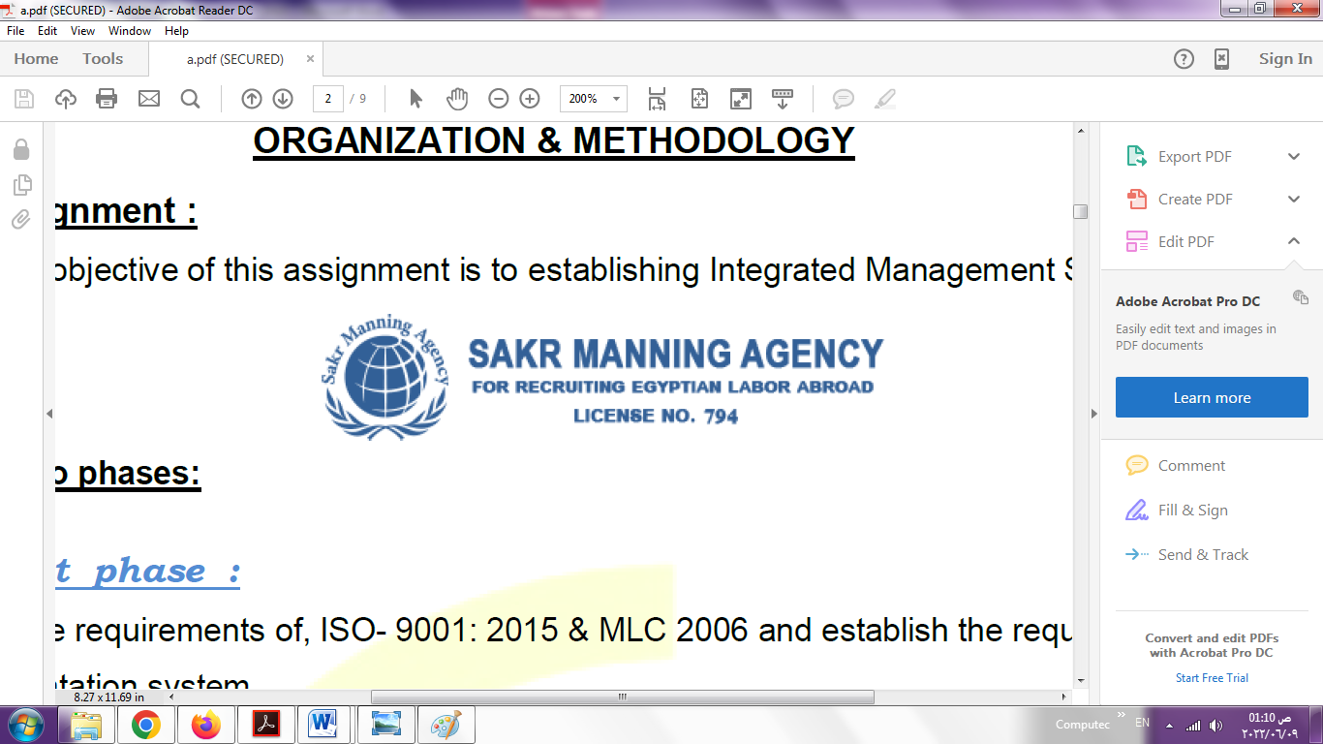 | SAKR MANNING AGENCY  FOR RECRUITING EGYPTIAN LABOR ABROAD | Issue Date | 15.05.2022
 |  | Revision Date | 01.02.2024
 | Crewing Management Manual  Seafarer Employment Application | Revision | 1.3
 |  | Page | 4
Application For Position as | 2nd Eng
Register Code. | EO-2.034
Other Position (If Any) | 3rd Eng
Register Date | 25/04/2024
Last up Date Data
Expected Salary / Available Date | 5000 USD/EUR.availabilty 20/4/2024



1. PERSONAL DETAILS
Full Name | IHAB FAROUK AHMED AHMED MOHAMED
Date Of Birth | 7/12/1974 |  |  |  |  |  | Marital Status |  |  |  |  |  | Single ☐ |  |  |  |  |  | Married ☐
Nationality | Egyptian |  |  |  |  |  | Height (Cm) |  |  |  |  |  | 169 |  |  |  | Weight (Kg) |  |  |  |  | 89
Place Of Birth | Dakahlia , Egypt |  |  |  |  |  | Overall Size |  |  |  |  |  | XXL |  |  |  | Shirt Size |  |  |  |  | XXL
Nearest Port | Cairo international airport |  |  |  |  |  | Trouser Size |  |  |  |  |  | XXL |  |  |  | Shoes Size |  |  |  |  | 44
2. EDUCATION
College / School | Faculty of engineering, Suez Canal University
Marline Test | Issued Date |  |  |  | Result % |  |  | Issued By (Authority) |  |  |  |  |  |  |  | Issued At
English Language | Fluent ☐ |  |  |  |  | Good ☐ |  |  |  |  |  | Average ☐ |  |  |  | Poor ☐
…French…… Language  ( ) | Fluent ☐ |  |  |  |  | Good ☐ |  |  |  |  |  | Average ☐ |  |  |  | Poor ☐
3. CONTACT DETAILS
Home Address / City | 35618 Atmeda, Mitghamer, Dakahlia, Egypt
E-Mail | ehabfarok@gmail.cm |  |  |  |  |  | Mobile / Tel |  |  | 00201010605325 |  |  |  |  |  |  |  | 0020504800273

4. TRAVEL DOCUMENTS
Type | Document No. |  |  | ISS. Date |  |  | Exp. Date |  |  |  | ISS. By (Authority) |  |  |  |  |  |  |  | Place of Issue
Passport | A30407603 |  |  | 15/05/2022 |  |  | 14/05/2029 |  |  |  | Egyptian Authority |  |  |  |  |  |  |  | Dakahlia
Seaman Book | S00015045 |  |  | 18/05/2021 |  |  | 29/03/2026 |  |  |  | EAMS |  |  |  |  |  |  |  | Alex.
Other Seaman Book | CY356038 |  |  | 27/01/2023 |  |  | 26/01/2033 |  |  |  | CSDM |  |  |  |  |  |  |  | Limassol

5. PROFESSIONAL QUALIFICATION / CERTIFICATE OF COMPETENCY
Certificate Name |  |  | Number | Issue Date |  |  |  |  | Expiry Date |  |  |  |  | Issued By |  |  |  |  |  |  | Issued At
COC ( Rank) 2nd Eng |  |  | 2861 | 27/04/2021 |  |  |  |  | 29/03/2026 |  |  |  |  | EAMS |  |  |  |  |  |  | Alex.
GOC |  |  |  |  |  |  |  |  |  |  |  |  |  | NTRA |  |  |  |  |  |  | Cairo
6. NEXT OF KIN / EMERGENCY CONTACT
Full Name |  | Farouk Ahmed Mohamed |  |  |  |  | Relationship |  |  |  |  | Father
Address / Country |  | Atmeda, Mitghamer, Dakahlia, Egypt
Tel. No./ Mobile |  | 0020504800344 |  |  |  |  | Email
7. HEALTH CERTIFICATES & VACCINATIONS
Flag State |  | Number |  |  | Issue Date |  |  |  | Expiry Date |  |  |  |  |  | Issued By |  |  |  |  | Issued At
International Medical |  | 2861 |  |  | 26/07/2023 |  |  |  | 25/07/2025 |  |  |  |  |  | EAMS |  |  |  |  | Alex.
Yellow Fever |  | - |  |  | 16/09/2017 |  |  |  | lifelong |  |  |  |  |  | Ministry of Health |  |  |  |  | Alex
Cholera |  | - |  |  | 16/09/2017 |  |  |  | lifelong |  |  |  |  |  | Ministry of Health |  |  |  |  | Alex
Covid-19 |  | Vaccination Name |  |  | First Dose |  |  |  | Second Dose |  |  |  |  |  | (Other Does or Remarks)
 |  | Johnson |  |  | 24/05/2022 |  |  |  | 17/07/2023

8. MARINE COURSES
Course Name | Number | Issue Date | Expiry Date | Issued By / At
Personal Survival Techniques | NPST 3690 | 20/04/2021 | 12/04/2026 | N.P.G.I / Alex
Proficiency In Personal Survival Techniques
Fire Prevention and Fire Fighting
Advanced Fire Prevention and Fire Fighting | NAFF 1455 | 20/04/2021 | 10/04/2026 | N.P.G.I / Alex
Elementary First Aid | NFA 3848 | 20/04/2021 | 12/04/2026 | N.P.G.I / Alex
Medical Care Studies
Personal Safety and Social Responsibilities | NPS 4099 | 20/04/2021 | 14/04/2026 | N.P.G.I / Alex
Proficiency Of Security Awareness Training Seafarers | NA 4977 | 18/04/2021 | 14/04/2026 | N.P.G.I / Alex
Proficiency as a ship Security officer ( PSSO )
Proficiency In Survival Craft & Rescue Boats | NC 23598 | 20/04/2021 | 10/04/2026 | N.P.G.I / Alex
G.M.D.S.S
Communications
Advanced Communications
ECDIS Advanced Simulator (Management Level)
ECDIS Simulator (Operation Level)
Prevention and Combating of Marine Pollution | NEC 630 | 13/04/2021 | N/A | N.P.G.I / Alex
Radar & ARPA Simulator and Search &rescue
ARPA Simulator and Search
Marine Radar and automatic Radar Plotting
Bridge resource Management (B.R.M)
Engine resource Management (E.R.M) | 21347/23/EG | 13/07/2023 | N/A | AAST/Alex
Navigational Watch keeping
Proficiency for Rating forming part of Navigational watch (II/4) |  |  |  | EAMS / Alex.
High voltage training – operation of ship (1000 Volt and More)
Passenger Safety Cargo Safety and Hull integrity | XNXD 143 | 1/10/2022 | 28/09/2027 | N.P.G.I / Alex
Crowd Management Training | XNXA 146 | 27/09/2022 | 23/09/2027 | N.P.G.I / Alex
Crisis Management and Human Behavior Training | XNXB 145 | 27/09/2022 | 25/09/2027 | N.P.G.I / Alex
Safety training for Personal Prov. Direct Passengers | XNXC 143 | 1/10/2022 | 26/09/2027 | N.P.G.I / Alex
Practical Ability to Prepare Meals and (MLC 2006)
Personal Hygiene and Envir. Protection (MLC 2006)
Safety and Health in the Provision Meals (MLC 2006)
Food Storage and inventory Control (MLC 2006)
Ships Cook Certificate (MLC 2006) |  |  |  | EAMS / Alex.
Abel Seafarer Deck
Proficiency for Abel Seafarer Deck ( II/5 ) |  |  |  | EAMS / Alex.
Engineering Watch keeping |  |  |  | EAMS / Alex.
Proficiency for Rating forming part of a watch in engine room
Abel Seafarer Engine
Proficiency for Abel Seafarer Engine ( III/5 ) |  |  |  | EAMS / Alex.
Electro Technical Rating
Proficiency for Electro Technical rating ( III/7 ) |  |  |  | EAMS / Alex.
D.p. induction/ d.p. advanced
D.p. operator (unlimited)
Others

 |  | 9 - COMPLETE SEA – SERVICE DETAILS
Name: |  |  |  |  |  |  | Rank: |  |  | Register Code:
Company Name |  |  | Rank | Vessel Name/IMO Number | Flag | Signed On |  | Signed Off |  | Period | Vessel Type |  | D.W.T./ G.R.T |  | Engine Type | BH/ KW |  | Reason for Sign off
Misr shipping Co. |  |  | Trainee Eng | SAQQARRA  8117031 | Egypt | 14/06/2000 |  | 25/11/2000 |  | 5 M/10D | Bulk |  | 45000 |  | B&W | 6911 |  | End of Contarct
Misr shipping Co. |  |  | 4th Eng | ABYDOS  8117017 | Egypt | 7/02/2002 |  | 22/09/2002 |  | 7 M/15D | Bulk |  | 45000 |  | B&W | 6911 |  | End of Contarct
Misr shipping Co. |  |  | 4th Eng | EDFU  9139256 | Egypt | 25/12/2002 |  | 6/07/2003 |  | 6 M/11D | Bulk |  | 71000 |  | MAN B&W | 8698 |  | End of Contarct
Misr shipping Co. |  |  | 4th Eng | DAHAB  8317590 | Egypt | 16/10/2003 |  | 25/12/2003 |  | 2 M/9D | Passenger |  | 9042 |  | MAK | 7200 |  | End of Contarct
National Navigation Co. |  |  | 3rd Eng | EDFU  9139256 | Egypt | 20/02/2004 |  | 2/09/2004 |  | 6 M/12D | Bulk |  | 71000 |  | MAN B&W | 8698 |  | End of Contarct
National Navigation Co. |  |  | 3rd Eng | ABURDEES  77211380 | Egypt | 23/12/2004 |  | 3/06/2005 |  | 5 M/10D | General Cargo |  | 10022 |  | B&W | 4926 |  | End of Contarct
Triumph Shipping Co. |  |  | 3rd Eng | ALHURREYA  9266487 | Egypt | 6/09/2006 |  | 6/02/2007 |  | 5 M/1D | RO-RO |  | 6542 |  | MAN B&W | 8400 |  | End of Contarct
Triumph Shipping Co. |  |  | 2nd Eng | ALHURREYA  9266487 | Egypt | 6/02/2007 |  | 19/05/2007 |  | 3 M/13D | RO-RO |  | 6542 |  | MAN B&W | 8400 |  | End of Contarct
National Navigation Co. |  |  | 3rd Eng | WADI FERAN  9460083 | Egypt | 28/06/2021 |  | 18/03/2022 |  | 8 M/20D | Bulk |  | 57200 |  | MAN B&W | 9480 |  | End of Contarct
United Marine Egypt |  |  | 2nd Eng | POSEIDON EXPRESS  8706040 | Cyprus | 1/10/2022 |  | 15/12/2022 |  | 2 M/15D | RO-PAX |  | 24727 |  | WARTSILA SULZER | 14400 |  | End of Contarct
United Marine Egypt |  |  | 2nd Eng | POSEIDON EXPRESS  8706040 | Cyprus | 1/03/2023 |  | 23/06/2023 |  | 3 M/23D | RO-PAX |  | 24727 |  | WARTSILA SULZER | 14400 |  | End of Contarct
Salamis Lines |  |  | 2nd Eng | AKRITAS  8020599 | Cyprus | 3/09/2023 |  | 3/04/2024 |  | 7 M/1D | RO-RO |  | 20381 |  | WARTSILA PEILSTICK | 13200 |  | End of Contarct
10. REFERENCES
No | Company / Management / Country |  |  |  |  |  | Position |  | Name |  |  | TEL |  | EMAIL
1 | Salamis Lines |  |  |  |  |  | DPA |  | IONIS ASFURA |  |  | +357 24-828272 |  | Io-dpa@salamis-lines.com
2 | United Marine Egypt |  |  |  |  |  | Port Engineer |  | Mohamed Abady |  |  | +2021090542233 |  | M-abacord@UMEgypt.com
11. DECLARATION
Please answer the following questions:
- Did you suffer, or presently suffer from, any disease likely to render you unfit for services at sea or likely to endanger the health of other persons on board?  If yes, please provide details _______________________________________________  ______________________________________________________________________ | ☐YES ☒NO
- Did you suffer any accident, which rendered you temporary and/or partially disabled? | ☐YES ☒NO
- Did you ever undergo psychiatric treatment | ☐YES ☒NO
- Are you addicted to alcohol or drugs of any kind? | ☐YES ☒NO
I hereby declare that the above facts and information are true and accurate. I further consent to the holding and processing by (i) the owners of any vessel on which I may be assigned from time to time and (ii) the Managers and any direct or indirect parent or subsidiary or associated or affiliated company of the Managers (together referred to as "the Companies") for the purposes of my employment, of personal data about me contained herein, or provided to any of the Companies at a later date, including with respect to personal and pensions administration, employee management and as required to comply with any laws, regulations or contracts applicable to any of the Companies or their businesses. I understand that this data will be stored in the Managers’ database for the purposes of my current or future employment arranged by the Managers. Further, I confirm that the above may involve the transfer of my personal data within the Managers’ organization.
Place__________Port Said_________________ Date ____14/04/2024_______________________ Signature ______Ehab Farouk________________________
12.For Office Use Only
Initial assessment of applicant for further recruitment
Comments

Responsible person

Name / Signature _______________________________________________ Date ________________________________

